FUNDAMENTAL ECO-VOCABULARY

The 3 R Words plus 1
REDUCE REUSE RECYCLE
REFUSE

ECOLOGY ECOSYSTEM
ENVIRONMENT

HABITAT

BIODOVERSITY

COMPOST DECOMPOSE
BIODEGRADABLE

POLLINATORS

CLIMATE CHANGE

CARBON FOOTPRINT

ECOLOGY is the branch of science that deals with the relationship of organisms to one another in their surroundings.
ENVIRONMENT is the surroundings in which people, animals and plants live in the natural world.
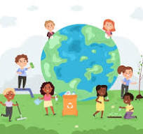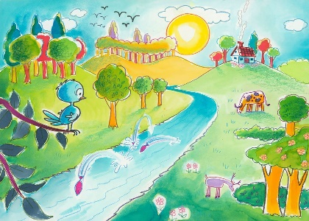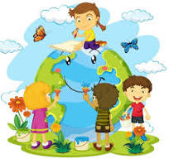

ECOSYSTEM is the complex network and interconnection of all living things
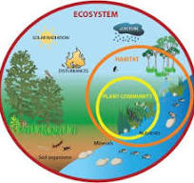
HABITAT is the natural home or environment for animals, plants and other organism
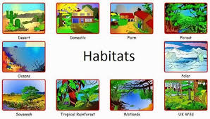
BIODIVERSITY is the variety of life in the world or in a particular habitat or ecosystem
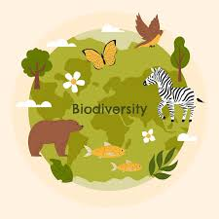
BIODEGRADABLE is a substance being capable of being decomposed by bacteria or other living organisms
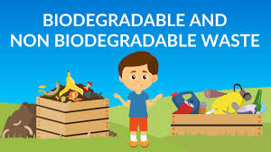

DECOMPOSE is the natural breakdown or organic materials.
This process equals COMPOST
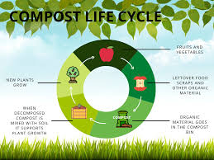
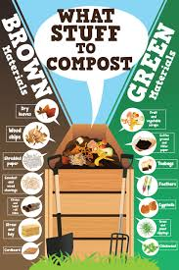
CARBON FOOTPRINT is the amount of carbon dioxide released into the air because of your own energy needs. You need transportation, electricity, food, clothing and other goods. Your choices can make a difference.
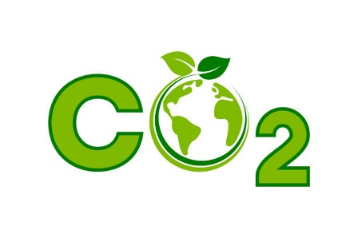

CLIMATE CHANGE describes a change in the typical weather for a region such as high and low temperatures and the amount of rainfall over a long period of time.

NASA CLIMATE KIDS https://climatekids.nasa.gov/
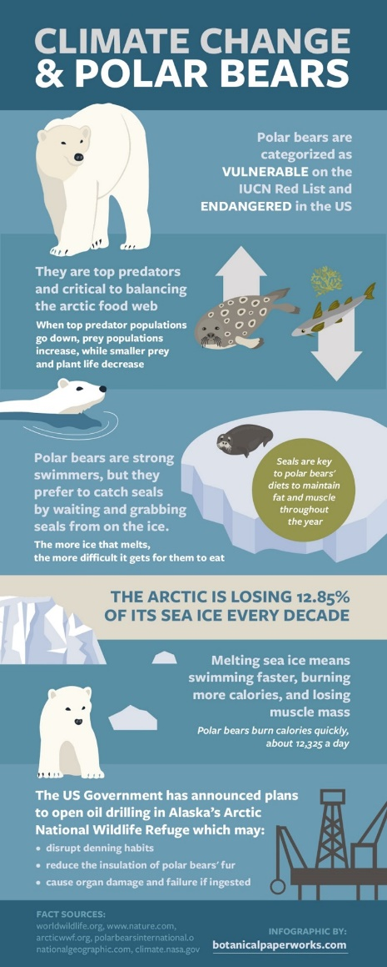

POLLINATORS see Planting for Pollinators in Grand Gardening

SAY NO TO PLASTIC
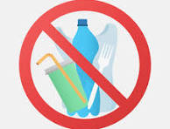

“UNWANTED” TREASURE HUNT –

A fun way for kids to teach parents and grandparents about single use plastic.
Have grandchildren look through the cupboards (with parental approval and help) in a simple game of I Spy for single use plastic. Keep a chart and take pictures to document the finds.
Team up with another family and have a weeklong challenge to see who finds the most “Unwanted” Treasure and then have a Plastic Free Picnic together. Check out Cooking Green for great kid food picnic ideas.
